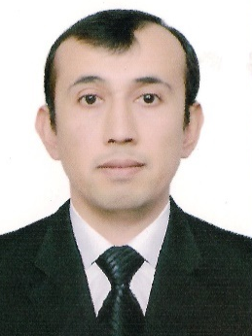
Rajabov Adkhamjon Khamdamovich

Since 2018.05.03:
Vice-Rector for Finance and Economic Affairs of the Samarkand state architectural and civil engineering institute.
Date of birth: Place of birth:
03.08.1981 Navoiy viloyat, Xatirchi tumani
Nationality: Member of party:
Uzbek yo’q
Education status: Graduated:
High education 2004 y. Samarkand state architectural and civil
engineering institute

Specialization in education: Environmental protection (SamSACEI, 2002y, Bachelor)
Water supply, sanitation and protection of water resources making and using them effectively (SamSACEI 2004 master's)
Scientific status:
PhD
Language skills:
Russian, basic English
Awarded with state awards (what kind):
None

MEHNAT FAOLIYaTI

1998-2002 yy. - Student of Samarkand state architectural and civil engineering institute
2002-2004 yy. - Master student of Samarkand state architectural and civil engineering institute
2005-2008 yy. - Graduate student of Samarkand state architectural and civil engineering institute
2000-2005 yy. - Samarkand state architectural and civil engineering institute electronic service center operator
2005-2009 yy. - Samarkand state architectural and civil engineering institute economist of the financial planning department
2009-2011 yy. - Samarkand state architectural and civil engineering institute head economist of the financial planning department
2011-2012 yy. - Samarkand state architectural and civil engineering institute acting head of financial planning department
2012-2017 yy. - Head of department of financial-planning department and head teacher of water supply and water resources protection department
2017-2018 yy. - acting vice-rector of Financial and economics of Samarkand state architectural and civil engineering institute
2018 y.-h.v. - vice-rector of Financial and economics of Samarkand state architectural and civil engineering institute

