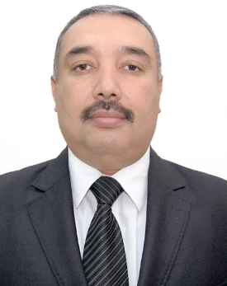

Buriyev Khakim Toshimovich

Since 18.08.2021:
Samarkand state architectural and civil engineering institute
Vice-rector of academic affairs
Date of birth: Place of birth:
    - Navai region, Nurota district
Nationality: Member of party:
o’zbek yo’q
Education status: Graduated:
High education 1993 y. Samarkand state architectural and civil
engineering institute
Ma’lumoti bo’yicha mutaxassisligi: Civil-engineer
Scientific status:
Associate professor of economic science
Language skill:
Russian
Awarded with state awards (what kind):
None

WORK EXPERIENCE

1986-1993 yy. - Student of Samarkand state architectural and civil engineering institute
1987-1989 yy. - on business vocation
1993-1995 yy. - Secretary of the committee of the Youth Union of the Samarkand state architectural and civil engineering institute
1995-1996 yy. - Assistant of the department of construction production technology of Samarkand state architectural and civil engineering institute
1996-2004 yy. - Assistant of the department of Construction Organization and Management of the Samarkand state architectural and civil engineering institute, leader of the KAMALOT youth organization of the institute.
2004-2008 yy. - Chairman of the joint trade union committee of the Samarkand state architectural and civil engineering institute
2008-2011 yy. - Vice-Rector for Finance and Economic Affairs of the Samarkand state architectural and civil engineering institute.
2011-2013 yy. - Senior lecturer of the department of Construction Management at the Samarkand state architectural and civil engineering institute
2013-2014 yy. - Associate professor of the department of Construction Management of the Samarkand state architectural and civil engineering institute.
2014-2015 yy. - Temporary head of the department of Construction Management of the Samarkand state architectural and civil engineering institute
2015-2021 yy. - Head of the Department of Construction Management of the Samarkand state architectural and civil engineering institute
2021 y.-h.q. - Vice-rector of academic affairs of Samarkand state architectural and civil engineering institute

